TRAFFIC MANAGEMENT PLAN
Traffic Management Plan Reference | .
Organisation | Contractor |  |  |  |  | Principal (Client)
 | Contractor Office Phone No. |  |  | Contractor Ref No. |  |  |  |  |  | RCA
Location | Road Name(s) |  |  |  | Road Level  (LV / L1) |  |  | Posted Speed Limit |  |  | From RP
 |  |  |  |  |  |  |  |  |  |  | To RP
Description of Activity
Work Programme  Consider significant stages, eg  - Road closures  - Detours  - No activity periods | Date and time:  Alternative Dates:
Road aspects affected (delete either Yes or No to show which aspects are affected)
Pedestrians affected?  Cyclists affected? |  | Yes No  Yes No | Property access affected?  Restricted parking affected? |  |  |  | Yes No  Yes No |  | Traffic lanes affected?  Delays or queuing likely? |  |  | Yes No  Yes No
Proposed/ Restricted Work Hours
Traffic Details  (Main Route) |  | AADT |  |  | Peak Hour Flow
Proposed Traffic Management Method |  | Active:
 |  | Unattended:
 |  | Night:
Proposed Speed Restrictions
Positive Traffic Management Measures
Contingency Plans |  | Generic Contingency Plan attached
Specific additional contingencies:
Public Notification
Personal Safety
On-Site Monitoring |  | Attended:  Unattended:  Overnight:  Other times:
Other Information  (eg. delay calcs, EED issues, temporary speed issues, etc) |  | Other Info
Layout Diagrams
EED Applicable? |  | Y/N |  |  |  |  |  | Attached Y/N
STMS |  | Name (STMS)  Cert No: |  |  |  |  |  | Phone (24 hours)
Traffic Controllers |  | Name (TC)  Cert No: |  |  |  |  |  | Phone (24 hours)
 |  | Name (TC 2) (if required)  Cert No: |  |  |  |  |  | Phone (24 hours)
TMP prepared accurately to represent site conditions and submitted by |  | Contractor/Applicant  Cert No: |  |  |  |  |  | Date  Phone (24 hours)
Requires Amendment |  | Engineer  Cert No: |  |  |  |  |  | Date
Approval of this TMP authorises the use of any regulatory signs included in the TMP or attached traffic management diagrams. This TMP is approved on the following basis:
- To the best of the approving Engineer’s/TMC’s judgment this TMP conforms to the requirements of Code of Practice for Temporary Traffic Management (CoPTTM).
- This plan is approved on the basis that the activity, the location and the road environment have been correctly represented by the applicant. Any inaccuracy in the portrayal of this information is the responsibility of the applicant.
- The STMS for the activity is reminded that it is the STMS’s duty to postpone, cancel or modify operations due to the adverse traffic, weather or other conditions that affect the safety of this site.
Opus
Approving Engineer:
(Print Name and Certificate Number)

Opus (Signature) (Date)
Acceptance by TMC:
(Print Name and Certificate Number)

(Signature) (Date)
Nelson City Council
Acceptance by TMC:
(Print Name and Certificate Number)

(Signature) (Date)
Tasman District Council
Acceptance by TMC:
(Print Name and Certificate Number)

(Signature) (Date)

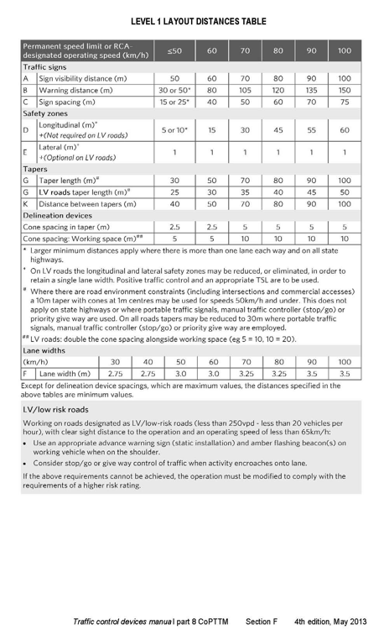
Temporary Traffic Management Appendix
Contingency Plan Requirements

Major Incident

Definition: A major incident is described as

- where fatality or injury is involved or a real potential exists
- where significant property damage is involved
- where emergency services (police, fire) control of the site is appropriate

The Contractor shall immediately conduct the following

- secure the site to prevent the prospect of (further) injury or damage
- render first aid to the extent qualified
- make contact with appropriate emergency authorities
- notify the Engineer

Incident

Definition: An incident is described as an event where the delay approved in the TMP is, or is likely to be, exceeded. The incident may include a non injury accident or structural failure of the road.

The Contractor shall immediately conduct the following:

- secure the site to prevent the prospect of injury or further damage
- notify the Engineer

The Contractor shall then…
Take reasonable steps to re-establish traffic movement providing that
- it is safe to do so and
- such action is approved by authorised officers of the NZ Police and the Department of Labour who are managing / investigating the incident.

Unless absolutely necessary for reasons of safety, the Contractor shall not move any TTM measures, without the Engineer’s express consent. This consent will not be granted without the agreement of authorised officers of the NZ Police and/ or the Department of Labour who are managing / investigating the incident.

When TTM measures are authorised to be moved they must first be suitably marked out on the road and photographed. The Engineer or RCA may conduct these actions following completion of their own investigations.

.

